**HINGA KIJYAMBERE PLATFORM**

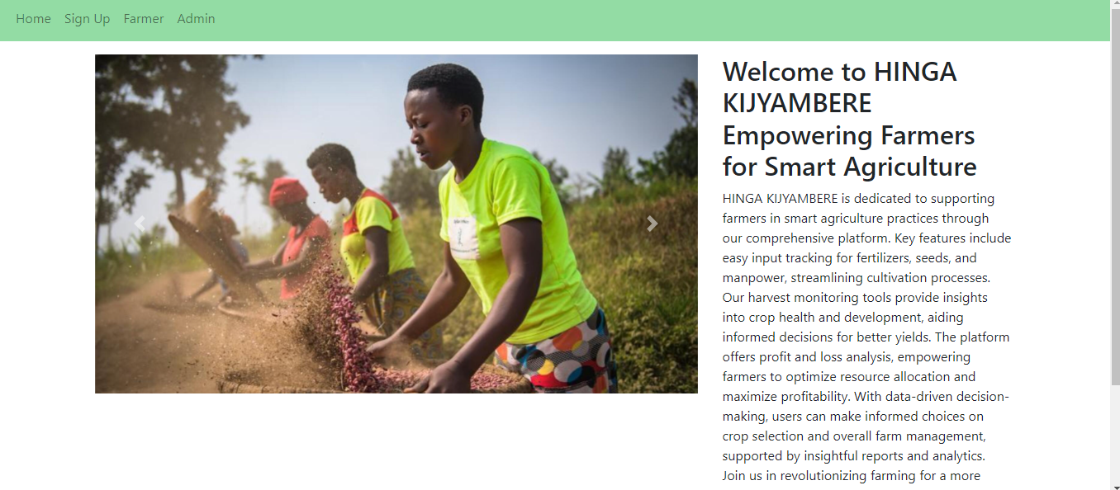

**Project Introduction:**

Briefly introduce your project: "HINGA KIJYAMBERE is a platform dedicated to supporting farmers in smart agriculture practices.

2. **Key Features**:

* Easy input tracking for fertilizers, seeds, and manpower.
* Streamlining cultivation processes.
* Harvest monitoring tools for insights into crop health and development.

3.Benefits:

* Informed decisions for better yields.
* Profit and loss analysis for optimizing resource allocation.
* Empowering farmers to maximize profitability.

**4.System Workflow:**

1. Supervisor Actions:

**Add Labor**:

Supervisors can input labor details, their names and other needed information into system 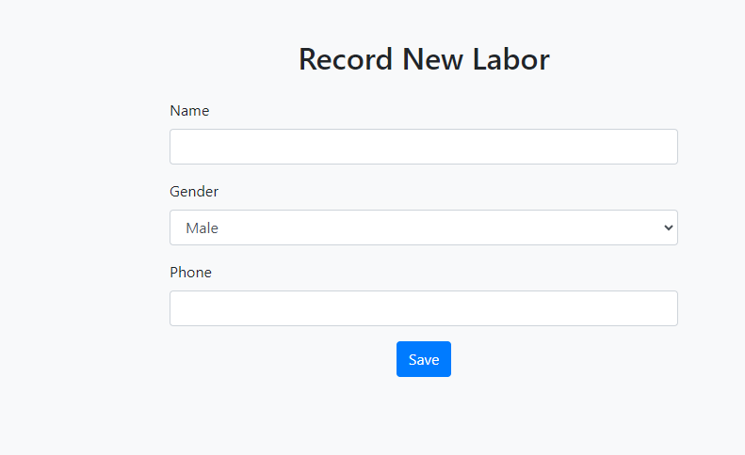

**Add Expenses**:

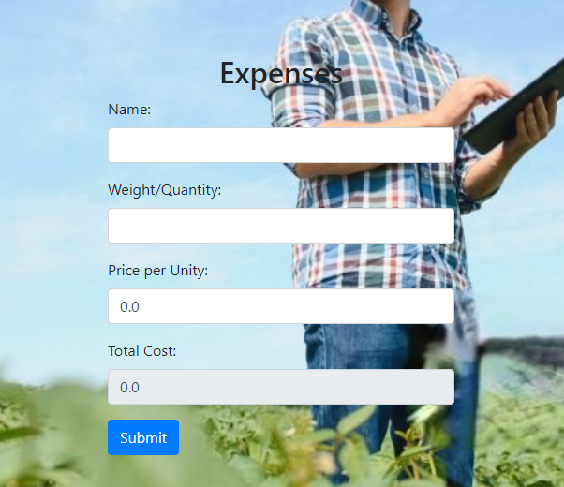

Input various expenses related to farming activities such as fertilizers, seeds, equipment, etc.

**Add Harvest**:

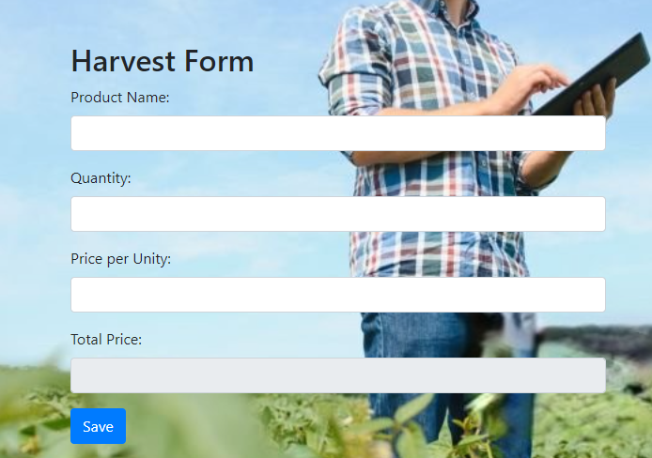

Record details of the harvested crops, including quantity and quality.

Update and Delete:

**Supervisors have the ability to update and delete entries for accuracy and data management.**

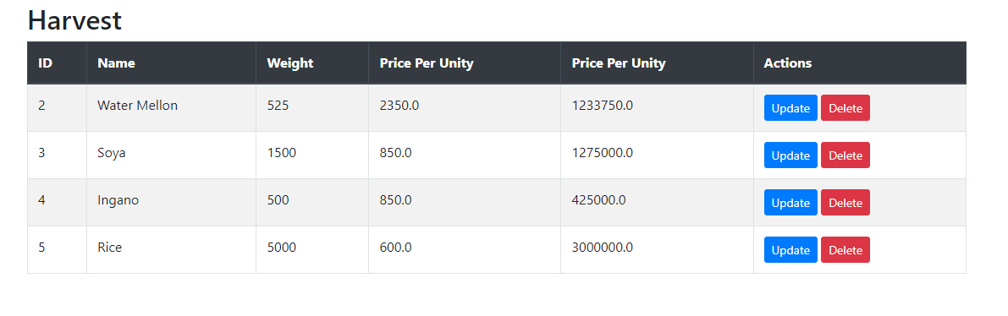

2**. Admin Actions (Supervisor Privileges + Additional):**

**Approval of Reports:**

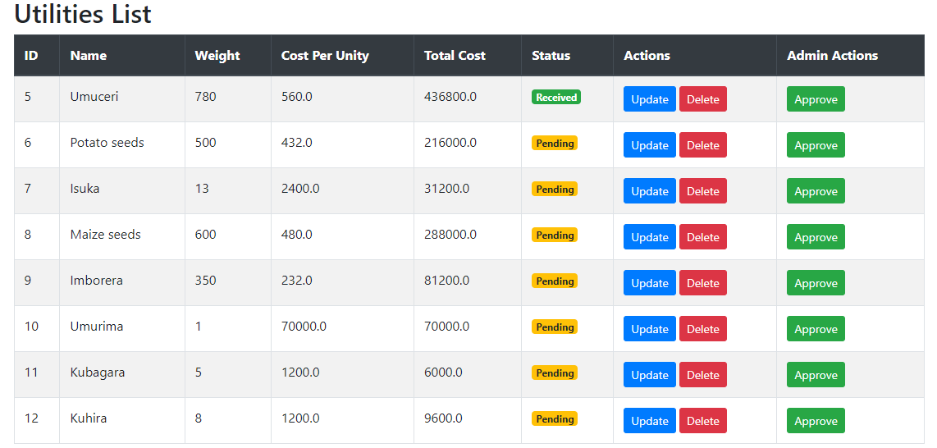

Admins can review and approve reports submitted by supervisors, ensuring data accuracy.

Advanced Reporting:

**Generate comprehensive reports on total expenses, total harvest, and profit/loss analysis.**

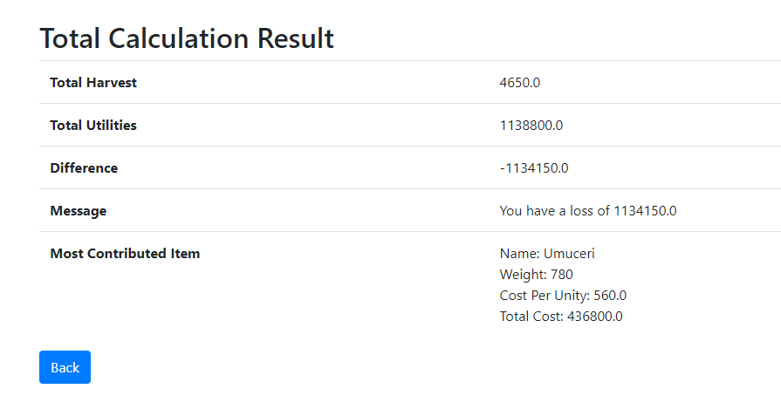

Identify the most significant contributors to expenses for better cost management.

3. Automated Reminders:

The system is equipped with automated reminders for crucial activities such as upcoming tasks, pending approvals, or time-sensitive activities like planting or harvesting seasons.

Reminders are sent via email to relevant users to ensure timely and efficient farm management.

Logging and auditing features to track changes made by users, ensuring accountability.